**WORKSHEET 6 – EOM Review**

**1 HOUR**

**15 MINS**

1. **List the preorder, inorder, and postorder traversals of the following binary tree:**

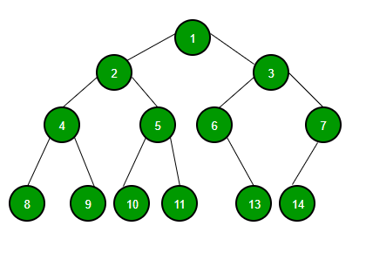

**Preorder:**

**Inorder:**

**Postorder:**

1. **Given an array ARR, write functions to find the minimum and maximum elements in it (pseudocode).**
2. 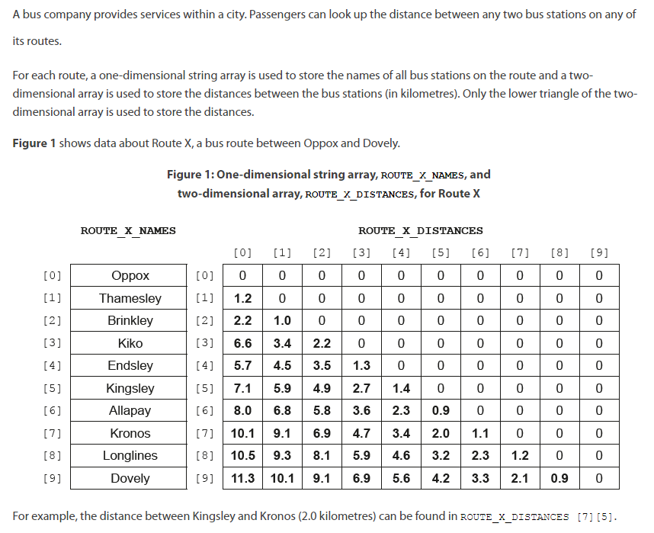
   1. **State the distance between Kiko and Longlines**
   2. **Construct a pseudocode algorithm that checks the elements of the array ROUTE_X_DISTANCES and outputs whether the array is valid or not.**
   3. **Construct a pseudocode algorithm that inputs the names of two bus stations and outputs the distance between them. If any of the inputted names are not found, the method should output an appropriate message.**
   4. **A screenshot of a math test

      Description automatically generated**
3. **Sketch (or diagram) the following linked lists including operations:**
   1. **Singly linked list**
   2. **Adding to a linked list**
   3. **Deleting from a linked list**
   4. **Doubly linked list**
   5. **Circular linked list**
4. **Create a table describing benefits and downsides of software as a service (SaaS).**
5. **Create a table comparing arrays to collections in pseudocode.**
6. **Write a binary search in pseudocode.**
7. **Write a bubble sort in pseudocode.**
8. **Write a selection sort in pseudocode.**
9. **Describe the 4 methods of changeover from an old system to a new system.**
10. **Identify 4 causes of data loss, and then state possible solutions for each of them.**
11. **List 4 different possible accessibility features that a computer system could have.**
12. **Define usability and describe 3 examples of usability concerns.**
13. **Outline what is meant by abstraction.**
14. **Define a prototype**
15. **Explain the benefits and drawbacks of a prototype**